Groups of the Periodic Table
Group 1: Alkali Metals
Group I(first column) of the periodic table. Sodium and potassium are examples of these elements. Alkali metals form salts and many other compounds. Form ions with a +1 charge. The alkali metals are highly reactive.
Group 2: Alkaline Earth Metals
The alkaline earths are located in Group II (second column) of the periodic table. Calcium and magnesium are examples of alkaline earths. These metals form many compounds. They have ions with a +2 charge.
Groups 3-12: Transition Metals
Iron and gold are examples of transition metals. These elements are very hard, with high melting points and boiling points. The transition metals are good electrical conductors and are very malleable. They form positively charged ions.
Metalloids
Some elements have some, but not all of the properties of the metals. These elements are called metalloids.
Group 17: Halogens
Examples of halogens are chlorine and iodine. You find these elements in bleaches, disinfectants, and salts. These nonmetals form ions with a -1 charge. The physical properties of the halogens vary. The halogens are highly reactive.
Group 18: Noble Gases
The noble gases are located in Group VIII of the periodic table. Helium and neon are examples of noble gases. These elements are used to make lighted signs, refrigerants, and lasers. The noble gases are not reactive. This is because they have little tendency to gain or lose electrons.
Hydrogen
Hydrogen has a single positive charge, like the alkali metals, but at room temperature, it is a gas that doesn't act like a metal. Therefore, hydrogen usually is labeled as a nonmetal.

Onto the blank periodic table
Label the tops of the groups(columns)going from 1 to 18.
Label group 1 as alkali metals
Label group 2 as alkaline earth metals.
Label group 18 as the noble gasses.
Label group 17 as the halogens.
Colour in boron, silicon, germanium, arsenic, antimony and tellurium and label them as the metalloids.
Label the rest as the transition metals.
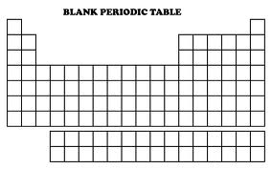
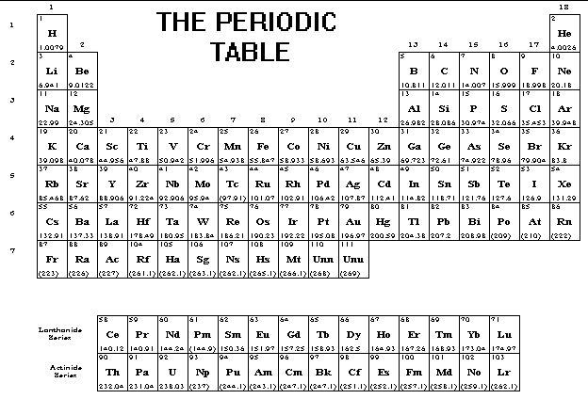

Element | Symbol | Group number | Name of the part of the Periodic table that the element is located in.
Iron | Fe | 8 | Transition metal
Lithium
 | Mg
 | He
Iodine
 | Si
Calcium
 | Na
Chlorine
 | O
Gold
 | Mg
 | Ne
Bromine

